Rayat Shikshan Sanstha’s
Karmaveer Bhaurao Patil College, Vashi, Navi Mumbai
[Autonomous]
Celebration of “AZADI KA AMRIT MAHOTSAV”from
9th Aug.2022 to 17th Aug.2022
Title of Activity: Singing of National Anthem
Date: 09.08.2022 & Time 11.00AM
Venue: Karmaveer Bhaurao Patil College Vashi Campus
- Number of students participated: 612 at college premise and about 1100
students in their classroom
2. Number of Teachers and nonteaching staff Participated: 212
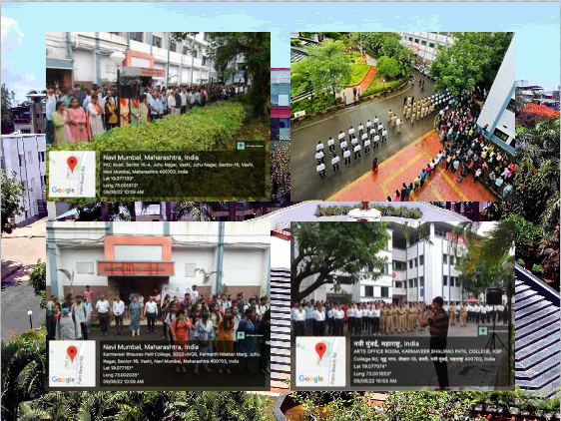
YouTube link: https://youtu.be/INnewKT80xA
As per the guidelines given by Government of India, all college students, teachers and non-teaching staff along with NCC Cadets and NSS Volunteers sang national anthem at 11.00 am with enthusiasm and pride to boost Unity amongst us.

Title of Activity: Cleanliness Drive
Date: 09.08.2022
Venue : College Classrooms, Lab and Campus
Activity Experience:
1. Number of students participated: 464
2. Number of Teachers Participated: 102
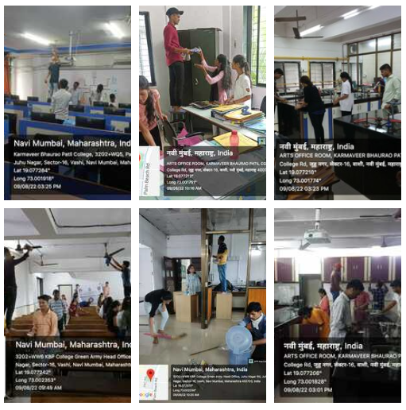Karmaveer Bhaurao Patil College, Vashi, Navi Mumbai, celebrated Cleanliness drive activity in whole college campus. All staff, students actively participated in cleaning activity.

Title of Activity: Raksha Bandhan with police force

Date: 10.08.2022 and 11.08.2022
Venue: Koparkhairne Police Station and College Campus
1. Number of students participated: 54
2. Number of Teachers Participated: 03
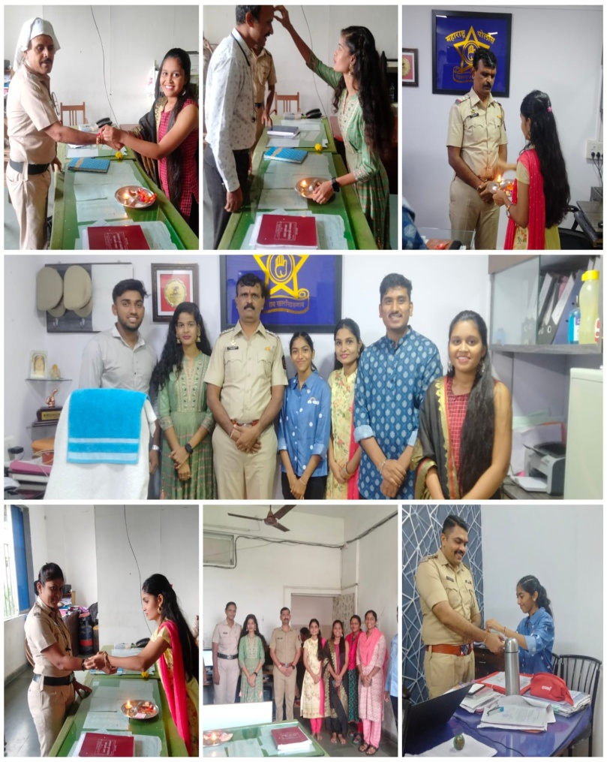

On the occasion of Raksha Bandhan NSS Volunteers tied rakhi to Navi Mumbai Police at Koparkhairne, also students lauded the policemen for improving their duty diligently to maintain law and order in the state even during festivals and holidays. NSS unit Purchase Rakhi from our Adivasi womens and selling it to college students and Sending Rakhi to our Indian Soldiers through Post office.

Title of Activity: Invited Talk on- History of Navi Mumbai By Hon. Lalit Pathak

Date: 11.08.2022 Time 3.00pm
Venue: Barr.P.G. Patil Auditorium. College Campus
1. Number of students participated: 50
2. Number of Teachers Participated: 200
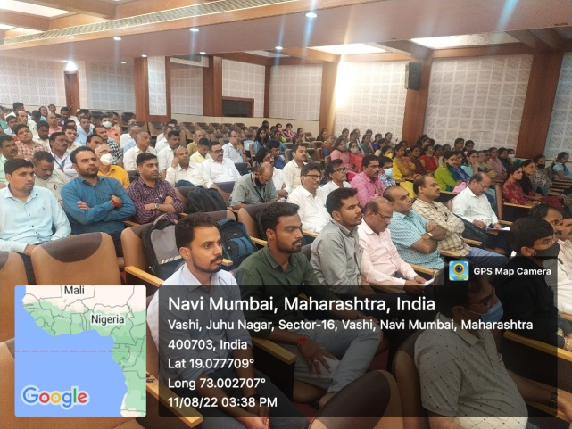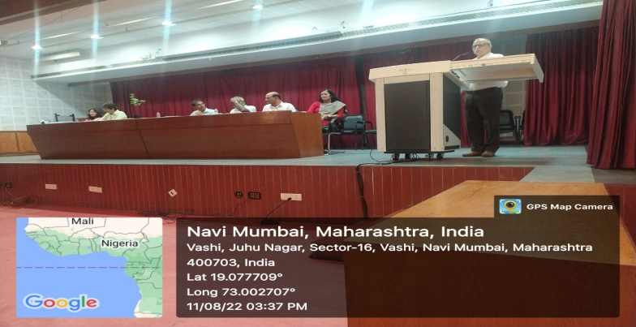

Title of Activity: Flag Distribution among college students and Staff
Date: 13.08.2022
Venue: Karmaveer Bhaurao Patil College Vashi Campus
- Number of flags distributed to students: 550, Flags for Rally: 100 from
NMMC c-ward Vashi
2. Number of flags distributed to Faculty members and Non-teaching Staff: 118 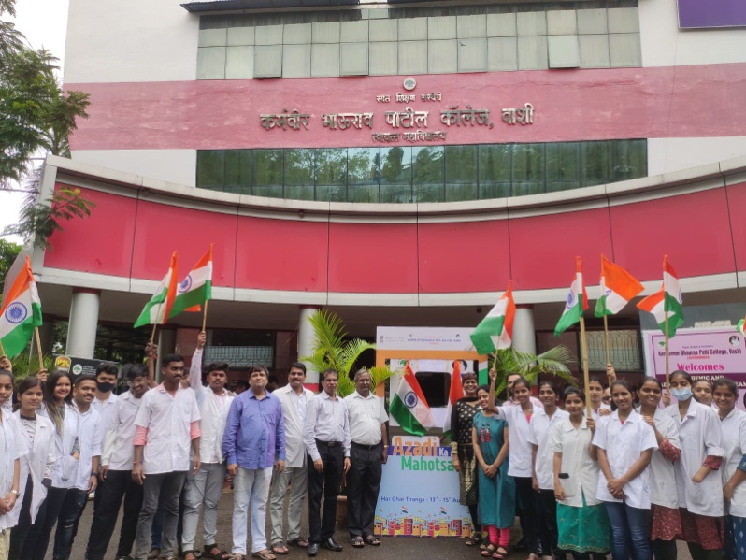 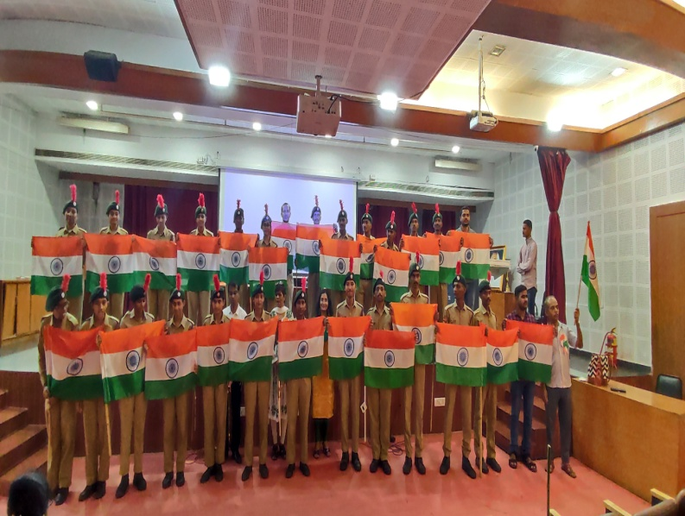 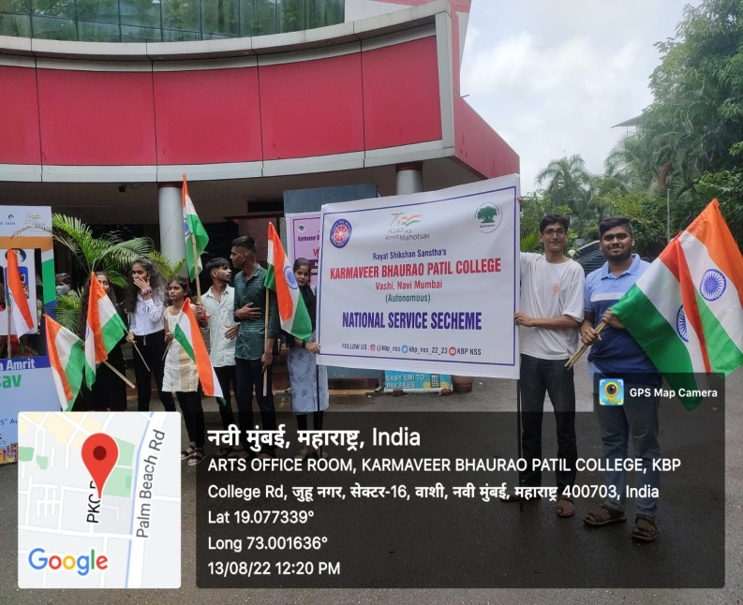
As the part of “Har Ghar Tiranga Celebration” Campaign, College library distributed 550 flags amongst students, Faculty members and non-teaching staff members, every college students, faculties and staff actively participated in “Selfi with Tiranga” campaign.

Title of Activity: Tree Plantation and Prabhat Pheri
Date: 14.08.2022
Venue: College Campus and Prabhat Pheri from College to Shivaji Chouk
1. Number of students participated: 548
2. Number of Faculty members and Non-teaching Staff: 122

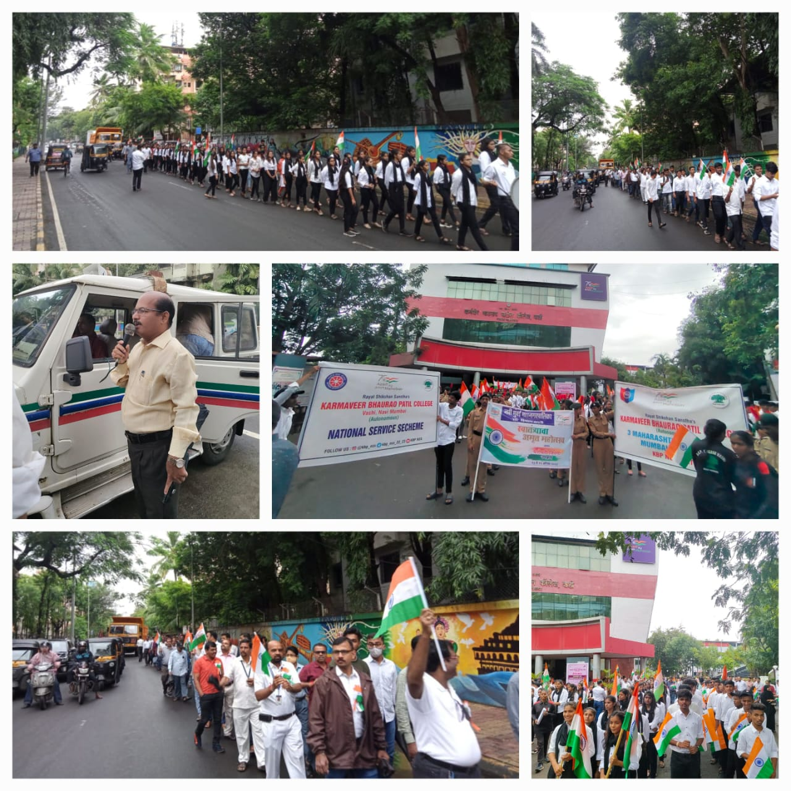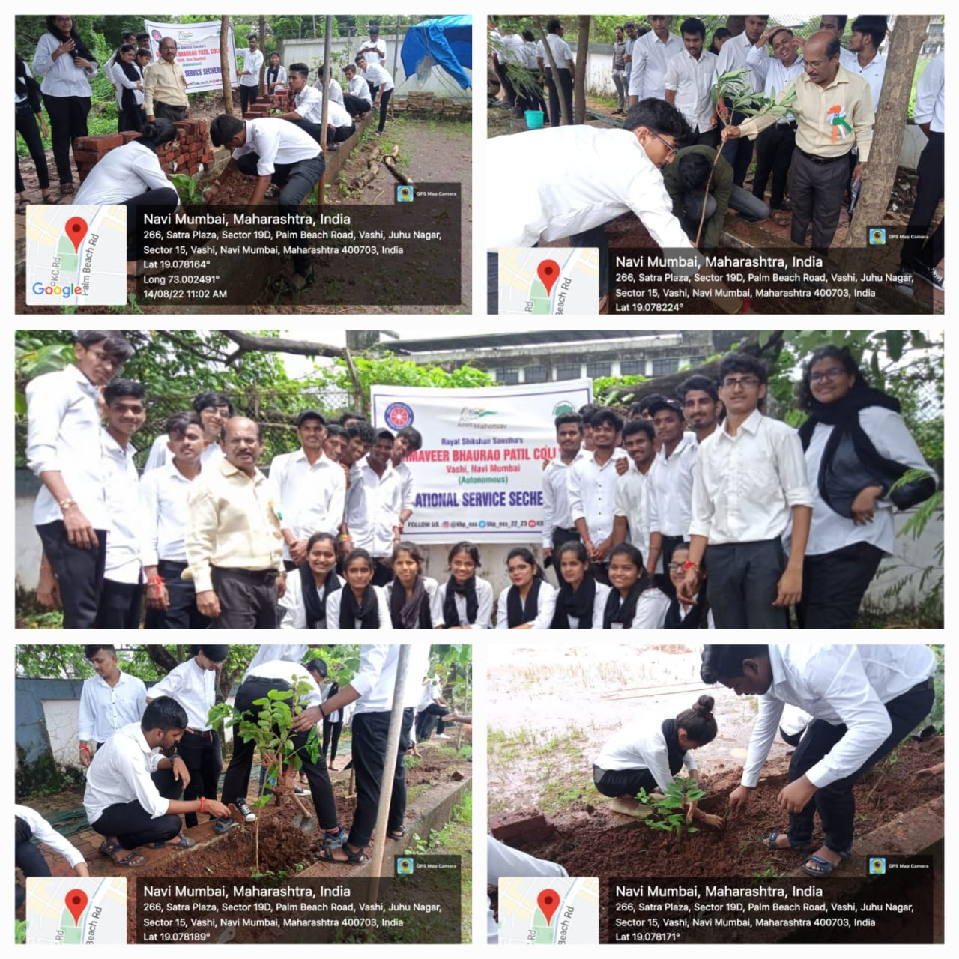
KBP College Vashi Students, faculty members and all the staff members took out a rally as a part of Har Ghar Tiranga campaign to mark the celebration of 75 years of independence to create awareness of the “Har Ghar Tiranga” initiative in Vashi Gaon, Shivaji Chauk and Gavdevi Mandir. The rally showed respect to the nation, army and security forces that always remain ready to sacrifice their lives for peace in the country.
KBP College Vashi reminded students about their duties towards Mother Nature on the occasion of Azadi Ka Amrit Mahotsav.As a part of environmental education “Go Green” initiative was taken to engage the entire college community in making a difference. Planting trees is the best way for spreading love and harmony. All staff members and students promised to protect the earth by planting plants and watering them in College campus.
Title of Activity: Celebration of 76th Independence Day

Date: 15.08.2022
Venue: Karmaveer Bhaurao Patil College Vashi Campus
1. Number of students participated: 418
2. Number of Faculty members and Non-teaching Staff: 132

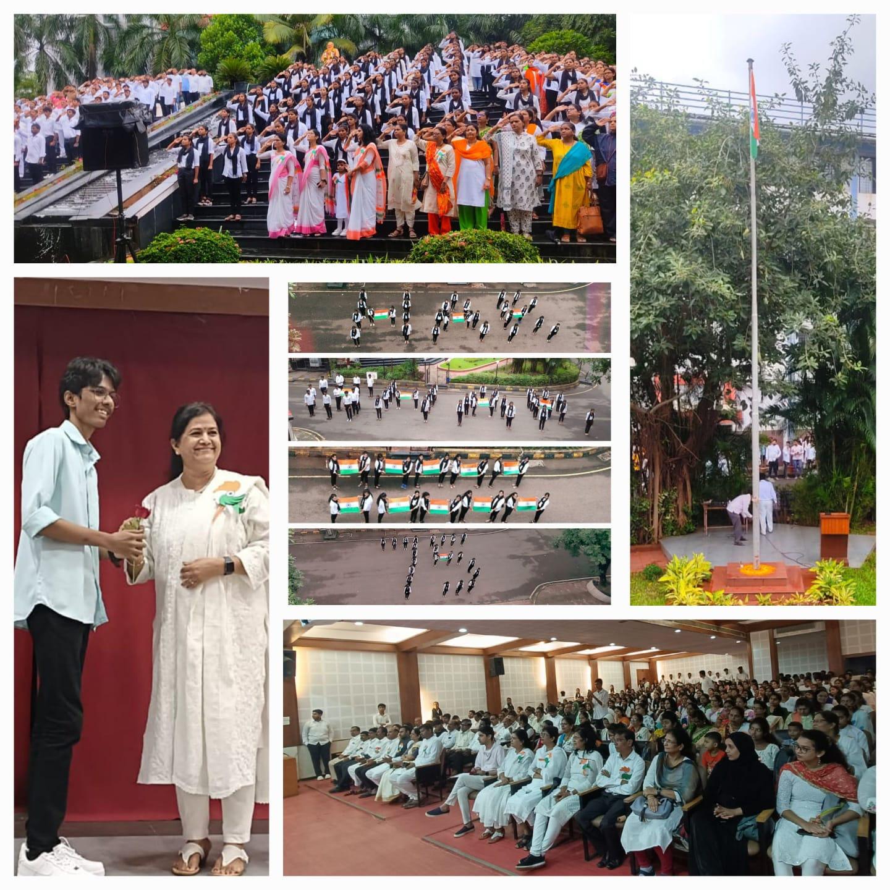
KBP College Vashi celebrated 76th Independence Day with flag hoisting by Hon.I/C Principal.Dr.Shubhda Nayak and address about the journey of India from 1947 to till date. Large numbers of students, NCC cadets, NSS Volunteers and Faculty members attended this ceremony. Principal also inaugurated poster presentation and patriotic songs competition of students.

Title of Activity: National Anthem
Date: 17.08.2022 & Time 11.00AM
Venue: Karmaveer Bhaurao Patil College Vashi Campus
- Number of students participated: 520 at college premise and about 1500
Students in their classroom
- Number of Teachers and nonteaching staff Participated: 212

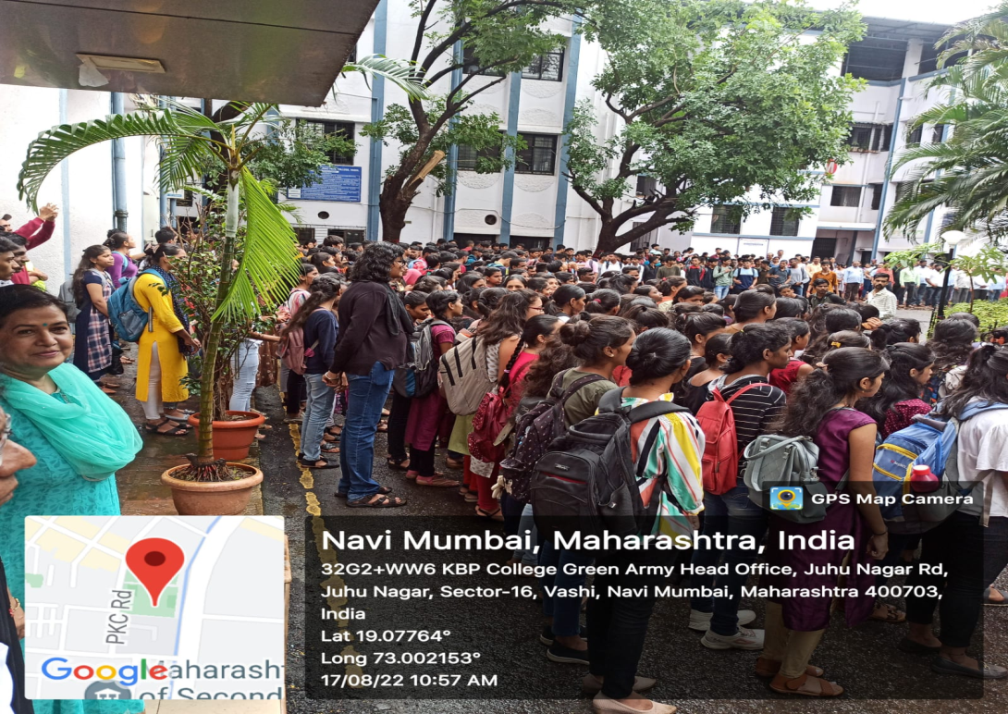

Title of Activity: Screening of petriotic movie-‘Stage of siege-Temple Attack’
Date: 17.08.2022 Time: 3.00pm to 5.00pm
Venue: Barr. P.G. Patil Audotorium College Campus .
1. Number of students participated: 270
2. Number of Faculty members and Non-teaching Staff: 25
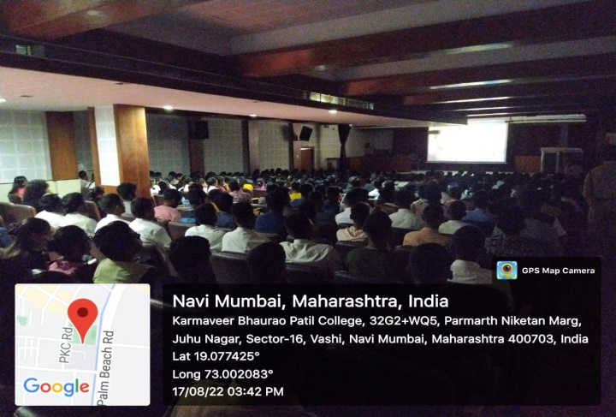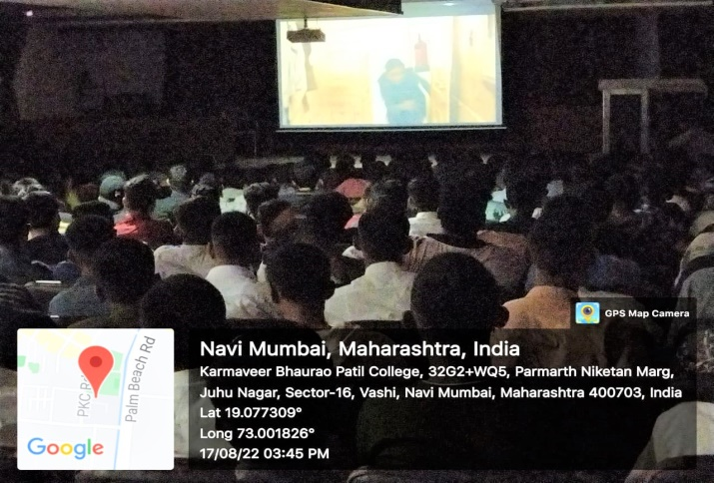
Col. Tushar Joshi (Sena Medal) who is commanding officer of 3MAH Battalion NCC Mumbai A group was directly involved in combating the temple attack at Akshardham, Gujarat. Based on that attack a patriotic movie is filmed which was shown to students and staff.

